QUIZ GAME
This ERD represents a Quiz System where teachers create quizzes with questions, users attempt the quizzes, and provide answers. The relationships between these entities are designed to capture the system’s functionality, ensuring data integrity and the ability to manage quizzes, user attempts, and answers effectively.
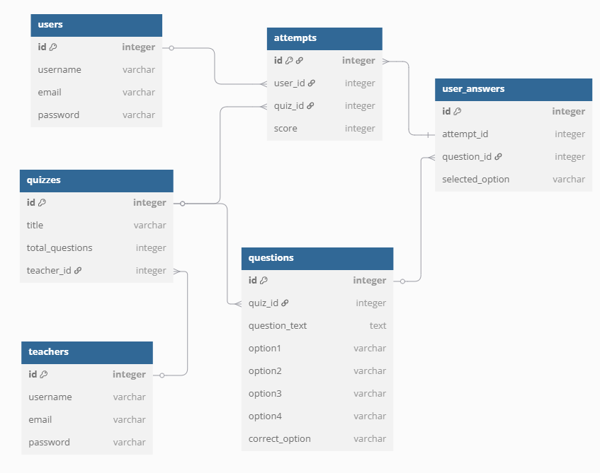

Users ↔ Attempts: One user can have many attempts.
Quizzes ↔ Questions: A quiz can have many questions.
Quizzes ↔ Attempts: A quiz can be attempted many times by different users.
Attempts ↔ User_Answers: A single attempt can have many answers.
Questions ↔ User_Answers: A question can have many answers across attempts.
Teachers ↔ Quizzes: A teacher can create many quizzes.

